https://www.facebook.com/profile.php?id=61552101637564&mibextid=ZbWKwL

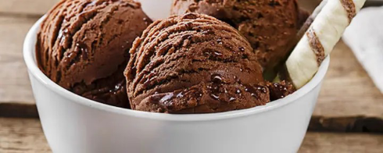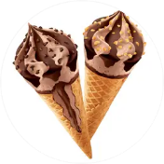

NK dairy products
Switch Proﬁles
NK dairy products
0 likes 1 follower
Ice cream is a frozen dairy product made by freezing the ice cream mix with agitation. It is composed
Message

Posts About Photos Mentions

Details
Page · Ice Cream Shop
Not yet rated (0 Reviews)

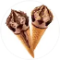
NK dairy products updated their
proﬁle picture.
Oct 11
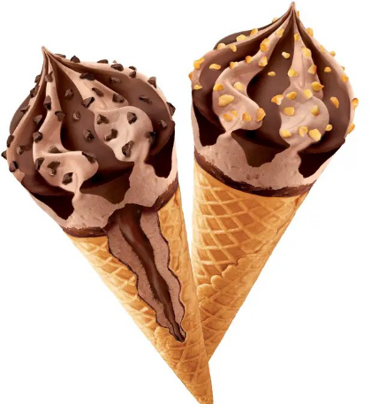

1
NK dairy products Switch Proﬁles

1

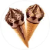
NK dairy products updated their
proﬁle picture.
Oct 11
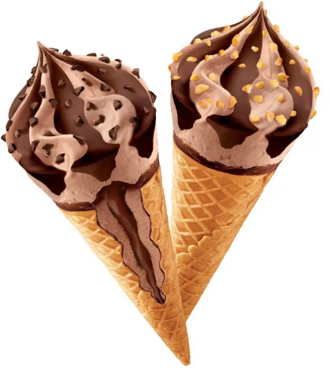
1
1

